**Kidbrooke Park [Music Festival](https://www.kpmusicfestival.org/) 2024**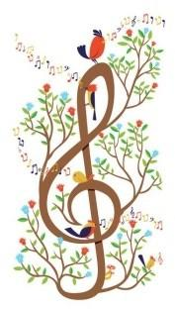

**APPLICATION FORM**

**KP Youth Orchestra**

*I would like my son/daughter to take part in the concert with members of some of* ***London’s Top Orchestras*** *on* ***Sunday November 3, 2024 at 3pm.***

My son/daughter will also take part in the rehearsal on:

* Friday **November 1** afternoon **2 - 5pm**
* Sunday **November 3** morning **10 - 11:30am**

Musician’s Name……………………………………………………

Age ……………

Instrument …………………………………………

Approximate grade ……….

Email address of parent/guardian…………………………………………

Please be aware that the youth orchestra places are limited. A late cancellation of a participant means a missed opportunity for another person, so please help us to avoid this by confirming that your child(ren) will commit to both rehearsals and the concert by ticking this box: ☐

I understand that there will be a charge towards costs of £20 per child, to be paid on application, either in cash or via PayPal using email address below. ☐

I would like my child to be considered for a TASEG Bursery ☐

*As Parent/Guardian, I give* **Kidbrooke Park Music Festival** *and it’s official staff my permission to take photos or otherwise capture the image of my child(ren) solely for use on the* **Kidbrooke Park Music Festival** *website. I grant* **Kidbrooke Park Music Festival** *the right to edit, use and reuse said products for the purpose mentioned above.*

I Agree ☐ Disagree ☐

Signature parent/guardian………………………………………………

Date……………………………………………..

Please return completed application form by email to

[kpmusicfestival@gmail.com](mailto:kpmusicfestival@gmail.com)